Living Wage Survey
Version Change Summary
Version | Date | Description of Change | Prepared by | Approved by
00 | [Insert Date] | Initial issue | [Name] | [Name]

1.Objective
The objective of this policy is to define xxxx

2. Scope
This policy applies to xxxx

3. Definitions and Acronyms
Term | Definition
Living Wage | The income level required for a worker to afford a decent standard of living.
Minimum Wage

4. Applicability to Social Compliance Standards
This document is developed in accordance with the requirements and principles outlined in the following international social compliance and certification standards:
- xxxx

5. Responsibilities
- HR Department:
- Site Managers:
- Compliance/CSR Team:
- Finance Department:
6. Procedure
6.1 Reference and Baseline Data
- Use national statistics (e.g., DOSM cost of living indicators) as a reference.
- Refer to third-party data from RSPO, Asia Floor Wage, or other verified studies.
6.2 Conducting Living Wage Surveys
- Use a standardized questionnaire form (Annex II) to collect information on actual household expenses.
- Survey categories must include: food, water, clothing, transport, healthcare, education, shelter, provisions, and social needs.
- Conduct separate surveys for local and migrant workers, accounting for family obligations abroad (for migrant workers).
- The survey is conducted by interviewing 30% of the workers each nationality.
- The survey shall ensure the workers anonymity and the management shall not interfere the result.
- The survey is re-conducted for every 5 years or any new changes in the Wage Policy of Malaysia.
6.3 Data Analysis
- Compare surveyed costs with the company’s average wage and minimum wage.
- Identify the Living Wage Gap and the difference between surveyed living wage and the living wage reference from DOSM.
6.4 Reporting and Action
- Compile findings into a report and present to management. The template of report is presented in Annex I.
- If gaps exist and more than 50%, develop action plans (e.g., progressive wage increase, in-kind benefits).
- Retain documentation for audit and verification.

7.0 References
7.1 Monthly Basic Expenditure for a Living Wage in Malaysia (DOSM, 2023)
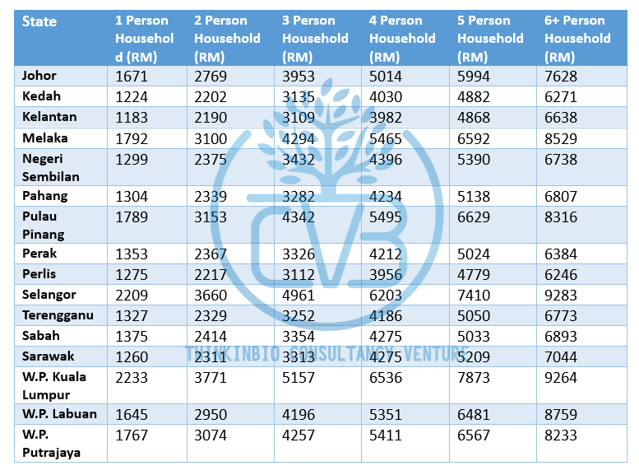

7.2 Decent living wage costs in Bangladesh, Kathmandu, Yangon and Banten in USD. (Sources: Asia Floor Wage Alliance, Nepal Household Budget Survey, Global Living Wage Coalition)
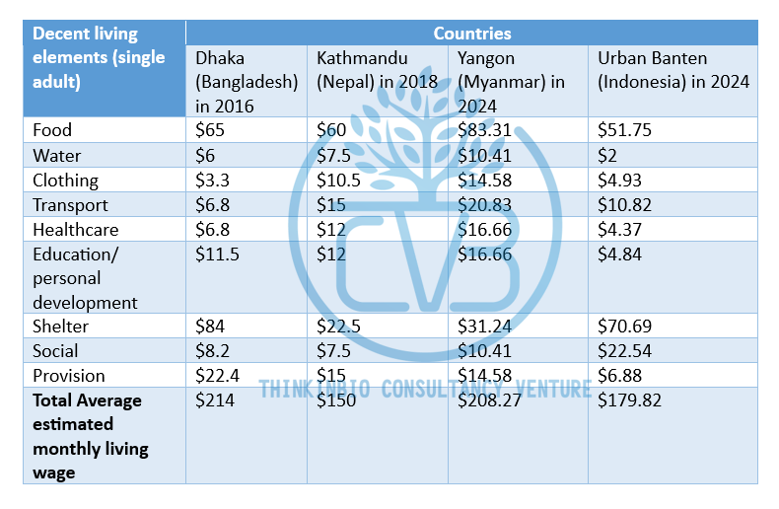

Annex I: Living Wage Survey in XXX company
Decent living elements | Cost of decent living based on number of households
Decent living elements | Single adult | Couple without children | Couple with 2 children | Couple with 3 children | Couple with 4 children | Couple with 5 children
Food
Water
Clothing
Transport
Healthcare
Education/ personal development
Provision
Shelter
Social
Surveyed decent living cost (annex II)
Average decent living cost
Legal Minimum Wage of Malaysia | MYR 1,700
Average Minimum Wage provided by company
Average total nett salary provided by company
Living Wage Gap
(Surveyed decent living cost - Average total nett salary provided by company)
Percentage of more than 1 working adult in the household among the workers | N/A

Comment:
- The average Minimum Wage provided by (Company Name) is MYR 1,700.
- The total number of employee samples are 120 workers out of 420 workers (50 Malaysian, 50 Bangladeshi and 20 Nepalese)
- The surveyed living wage is 20% higher than the minimum wage of Malaysia
- The surveyed living wage is 15% lower than the living wage from DOSM.
- The average percentage of more than 1 working adult in the household in (Company Name) for all types of household number is 99%.
- Conclusion: Workers do not live in extreme poverty. The wages paid to workers including foreign workers are sufficient to meet their basic needs and maintain a decent standard of living in Malaysia (for foreign workers: and support their families in their home country).

Prepared by: Signature, Name and Position
Prepared on: Date

Reviewed by: Signature, Name and Position
Reviewed on: Date

Approved by: Signature, Name and Position
Approved on: Date
Company Stamp

Annex II: Living Wage Survey Questionnaire
Purpose of This Survey
This survey is conducted to understand the actual cost of living for general workers like you. It helps our company assess whether the wages provided are enough to support a decent and healthy life — including food, housing, transport, healthcare, and other basic needs. Your responses are completely anonymous. This is not a request for salary adjustment. We kindly ask you to provide honest and accurate information so that we can improve our understanding of living costs.
Section 1: Basic Information (No Names Required)
- Gender:
☐ Male ☐ Female ☐ Other ☐ Prefer not to say
- Age Group:
☐ Under 20 ☐ 21–30 ☐ 31–40 ☐ 41–50 ☐ 51+
- Are you a:
☐ Local Worker (Malaysian) ☐ Migrant Worker (from another country)
- Marital Status:
☐ Single ☐ Married (no children) ☐ Married (with children)
- How many people live in your household (including you)?
____ persons
- How many people in your household are working?
____ persons
- How many children do you have (under 18 years old)?
______ persons

Section 2: Please estimate your household’s monthly spending in each category.
Category | Amount (RM) | Notes (if any)
1. Food
2. Drinking water
3. Clothing
4. Transportation (fuel, bus, etc.)
5. Healthcare / medical
6. Education / personal development
7. Housing / rent / utilities |  | Include electricity, water
8. Social activities (festivals, visits) |  | Include phone utilities
9. Emergency / savings / provision
Total monthly cost

Section 3: Other Details
- Do you support any family members in your home country (for migrant workers)?
☐ Yes ☐ No
If yes, how many people? ____
- Do you feel your current salary and your other working family member in the household (if any) is enough to cover all the above expenses?
☐ Yes ☐ No ☐ Sometimes
- Would you be willing to participate in follow-up interviews (still anonymous)?
☐ Yes ☐ No

Thank You for Your Participation
Your honest answers will help us better understand the cost of living and support efforts to ensure fair and responsible employment practices.

